LBT PROJECT

2 X 8,4 OPTICAL TELESCOPE

Technical Report

Aluminizing Belljar Structure

- SCOPE OF WORK

This document reports on the Belljar structural analysis.

Two additional interface flanges have been added to the Belljar lower structure to support the mechanical pumps.

The effect of the mechanical pumps weight is studied for the relevant load cases.

Two additional boundary conditions are studied, namely the Belljar held on the two lateral bearings for transportation and the Belljar fixed by a provisional interface ring during the machining process.

- BELLJAR FE ANALYSIS

The Belljar is modeled by shell elements according to the geometry of drawings n° 821a004 and 821a005. Hereafter the characteristics of the structure and the material used (steel) are reported:

- Young modulus 21e10 N/m²
- Poisson ratio 0.3
- Mass density 7850 Kg/m³

- CG coordinates (0 ; -137 ; 1292) mm (see figure 1 for reference system)
- Total structural weight 166585 N

Figure 1. The finite element model and the reference system used.
The Belljar vacuum flange lies in the XY plane.

Five different load cases have been studied, each one representing a separate step of the handling and vacuum operations. Except for load case 5, gravity acts in the –Y direction:

- Belljar lifted by two spherical hinges in P1 and P2 and vertically guided (Y direction) in P6 (located on the vacuum flange).
- Belljar resting on two spherical hinges in P3 and P4 and vertically guided (Y direction) in P5 (located on the vacuum flange, opposite to P6).
- Belljar resting onto the vacuum flange through the points F and H (spherical hinges) and vertically guided (Y direction) in P5.
- Belljar resting onto the vacuum flange through the points F, H and D (spherical hinges) with mechanical pumps load effect.
- Belljar completely constrained in the six locking devices points (A,B,E,F,G,H) and laterally supported (Z direction displacements = 0) on the whole vacuum flange. As in the previous load cases, gravity acts in the –Y direction and a 0.67 atm depression is applied.
- The same as load case 4 except for the gravity force direction, now along –Z axis and for the depression value, now increased up to 1 atm (Test conditions @ workshop).

Hereafter, the main FE results for the different load cases are graphically presented; tables 1÷6 summarized the main points displacements for the load cases studied.

Load case 1.

σ_{max} = 1.9 Kg/mm² near P1 and P2 (suspension points).

Figure 2. 1st load case deformation. Main displacements [mm].

Load case 2.

σ_{max} = 1.9 Kg/mm² near P3 and P4 (resting points).

Figure 3. 2nd load case deformation. Main displacements [mm].

Load case 3.

σ_{max} = 4.5 Kg/mm² near F and H (resting points)

Figure 4. 3rd load case deformation. Main displacements [mm].
Load case 4.

σ_{max} = 2.91 Kg/mm² near F,H and D (resting points).

Figure 5. 4th load case deformation. Main displacements [mm].

Load case 5.

σ_{max} = 5.6 Kg/mm² near the taps’ bases

Figure 6. 5th load case deformation. Main displacements [mm].

Load case 6.

σ_{max} = 8.7 Kg/mm² near the taps’ bases

Figure 7. 6th load case deformation. Main displacements [mm].

Further details can be worked out through the following tables. For the first four load cases, the six locking devices displacements are reported (X, Y, Z directions). For the last two load cases, only the max. taps displacement and the max. radial slip of the vacuum flange are given.
A
B
C
D
E
G
H
F
g
x
y

[mm] | A | B | C | D | E | F | G | H
Δx | 1.35 | -1.44 | 0.00 | 0.00 | 0.21 | -0.18 | -0.20 | 0.11
Δy | -0.41 | -0.41 | -1.65 | 1.06 | 0.56 | -1.32 | 0.58 | -1.33
Δz | -1.74 | -1.80 | 0.00 | 0.57 | 0.01 | -0.44 | 0.01 | -0.40

Table 1. 1st load case. Locking devices and diameter displacements.

[mm] | A | B | C | D | E | F | G | H
Δx | -1.21 | 1.25 | 0.00 | 0.04 | -0.14 | 0.11 | 0.22 | -0.11
Δy | -0.31 | -0.31 | 0.73 | -1.61 | -1.15 | 0.50 | -1.14 | 0.48
Δz | 1.55 | 1.61 | -0.44 | 0.00 | 0.43 | 0.00 | 0.48 | 0.00

Table 2. 2nd load case. Locking devices and diameter displacements.

[mm] | A | B | C | D | E | F | G | H
Δx | -5.07 | 5.09 | 0.00 | 0.01 | -0.82 | 0.13 | 0.84 | -0.13
Δy | -3.57 | -3.59 | 0.37 | -9.19 | -7.04 | 0.07 | -7.06 | 0.07
Δz | 6.84 | 6.85 | -1.35 | 0.00 | 2.15 | 0.32 | 2.15 | 0.32

Table 3. 3rd load case. Locking devices and diameter displacements.

[mm] | A | B | C | D | E | F | G | H
Δx | -0.778 | 0.774 | 0.000 | 0.000 | 0.359 | 0.000 | -0.359 | 0.000
Δy | -1.171 | -1.168 | 0.009 | 0.000 | -1.228 | 0.000 | -1.225 | 0.000
Δz | 0.663 | 0.665 | -0.294 | 0.000 | -0.234 | 0.000 | -0.230 | 0.000

Table 4. 4th load case. Locking devices and diameter displacements.

[mm] | Load case 5 | Load case 6
Δz* | -2.00 | -3.07
Radial slip | 0.2 | 0.2
* measured at taps’ center.

Table 5. 5th & 6th load case. Max. taps displacement and max. radial slip.

- BELLJAR / M1CELL FLANGES DEFORMATIONS

This paragraph reports on the Belljar o-ring load conditions for the vacuum test and the mirror Al plating.
The Belljar and the Mirror Cell are modelled as attached by the six fixtures only and the other parts of the two flanges are left free to move independently. This is clearly an assumption that does not model the actual boundary conditions.
The goal is to understand the order of magnitude of the “free” deformations of the flanges.
The system is analyzed in five different conditions:
1a) horizontal cell on 5 supports (without mirror inside the cell and Al stuff on the BJ)
– gravity loads;
1b) horizontal cell on 5 supports (without mirror inside the cell and Al stuff on the BJ)
- gravity loads and
- 1 atm pressure load;
2a) vertical cell on 9 supports (without mirror inside the cell and Al stuff on the BJ)
- gravity loads;
2a’) vertical cell on 9 supports (without mirror inside the cell and Al stuff on the BJ)
- gravity loads
- flanges partially constrained;
2b) vertical cell on 9 supports (without mirror inside the cell and Al stuff on the BJ)
- gravity loads
- 0.67 atm pressure load.

The worst case in terms of flange separation occurs at load case 2a).
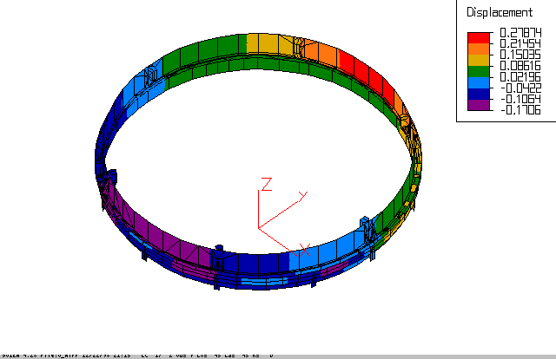

Figure 8. Belljar – M1 cell flanges. Z displacement [mm].
Own weight only, vertical plane.

The gravity load acts in the –Y direction, and the flanges tend to separate in the upper part. As can be seen from the colors, the max clearance is less than 0.2 mm.
Given this differential deformation, a specification of 1 mm overall flange planarity (both for the cell and the Belljar ones) would still assure the o-ring sealing capability.
This result is validated by restraining the out of plane displacements of the zones where the two plates would overlap (load case 2a’). The max separation is confirmed.

The flanges in plane relative displacements are reported to study the consequent stress on the sealing.

Load case | Δx [mm] | Δy [mm]
1a | 0.12 | 0.12
1b | 1.00 | 2.00
2a | 0.12 | 0.20
2b | 1.00 | 1.00

Table 6. M1 cell – Belljar flanges relative displacements.

- LOCKING DEVICE INTERFACE ANALYSIS

For what concerns the locking devices loading we analyzed the L.C. 2a) that is considered being the design condition.

The locking devices are identified according to the following scheme (view from BJ top):
A
B
C
D
E
G
H
F
g
x
y

The loads on the six attachments are:

Item # | Tensile (kN) | Shear (kN) | Bending (Nm)
E | 23.5 | 25.8 , 21.9 | 357 , 475
G | 19.0 | 25.4 , 24.8 | 621 , 545
A | -2.3 | 63.4 , 0.06 | 3.6 , 1251
B | -2.3 | 60.3 , 0.74 | 21.4 , 1463
H | -25.7 | 30.5 , 25.8 | 658 , 908
F | -21.5 | 29.2 , 27.9 | 591 , 567

Table 7. Locking devices loads.

The axial load on each locking device is well within the limit of 60 kN specified for such mechanism.

Given the max load that can be introduced by each locking device into the structure a detailed FEA is run to verify the structure integrity at the interfaces.

The model includes (see figure 9):
- a section of the locking device interface flanges on the Belljar, with three sides restrained to model the effect of the reinforcement ribs and the Belljar vertical plate;
- a section of the hung plate that is attached to the cell structure.

Figure 9 FEM of the locking device interface structure.

The 60 kN max load is applied to the two flanges.

BY keeping the plates size as per drawing 821a008, the max Von Mises stress level reaches 21 Kg/mm² on the lower plate.

By augmenting the lower plate thickness from the original 20 mm value to 25 mm the max Von Mises stress becomes 16 Kg/mm² and the max displacement reduces to 0.21 mm.

Figures 10 and 11 reports the stress and displacement patterns for the 25 mm layout.
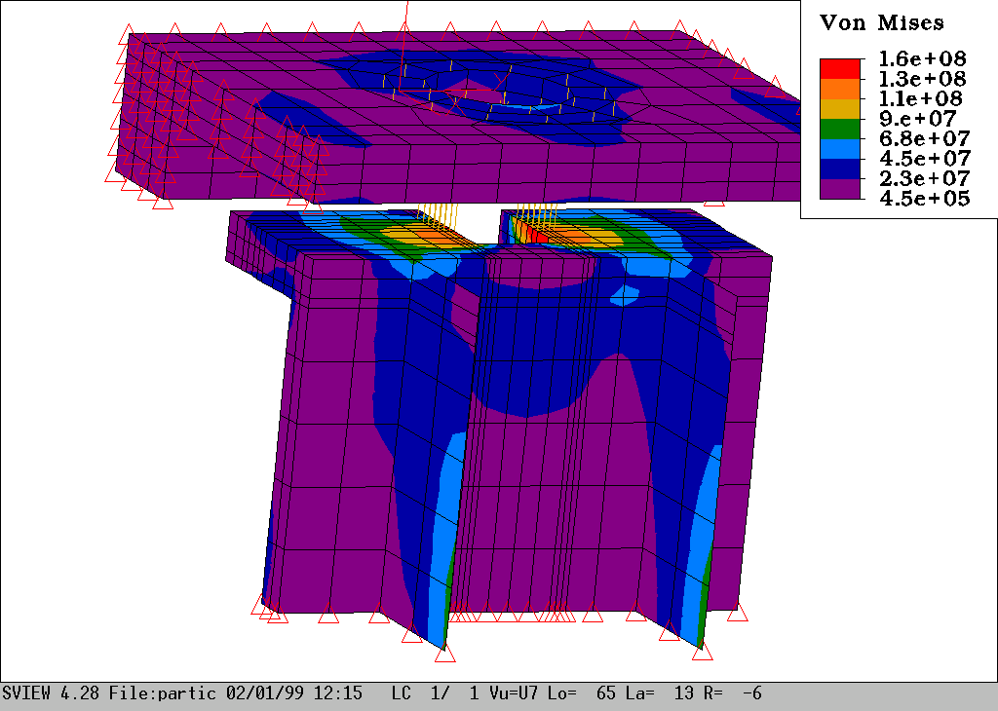

Figure 10 FEM of the locking device interface structure. VM stresses [Pa ]

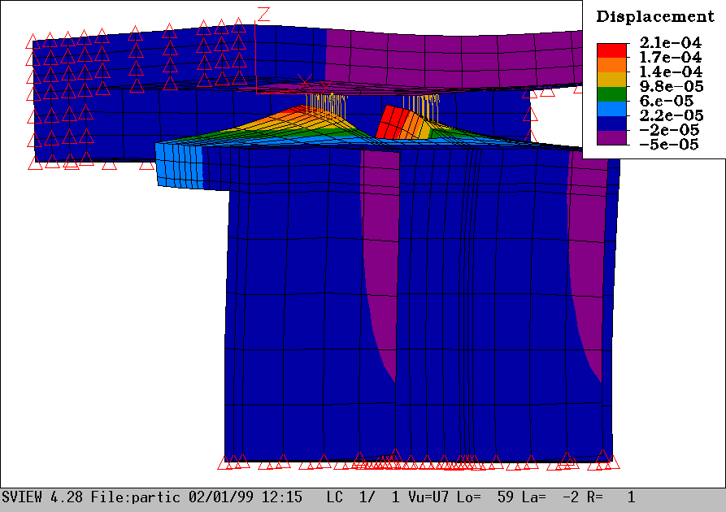

Figure 11 FEM of the locking device interface structure. Z displacements [m]

- MECHANICAL PUMPS LOAD STRUCTURAL EFFECTS

This paragraph reports on the mechanical pumps loading effects in terms of displacement of the locking devices interface points.
The FE model has been updated in order to describe the pumps and their support structure. As anticipated, the pumps’ support is attached to the Belljar by means of the two new interface flanges (figure 10).

Figure 10. Belljar FE model: pumps’ support & masses distribution (2600 Kg)

The two pumps are modeled as two lumped masses groups, each one made of 390 Kg + 455 Kg + 455 Kg elements (from outside to Belljar axis respectively).

The model weight, including the support structure, increases up to 197856 N.

Tables 8÷11 report the displacements of the locking devices location points.

[mm] | A | B | C | D | E | F | G | H
Δx | 1.43 | -1.47 | 0.00 | 0.00 | 0.23 | -0.14 | -0.22 | 0.08
Δy | -0.50 | -0.50 | -1.62 | 1.08 | 0.54 | -1.37 | 0.56 | -1.37
Δz | -1.76 | -1.81 | 0.00 | 0.60 | 0.00 | -0.40 | 0.00 | -0.36

Table 8. 1st load case. Locking devices and diameter displacements.

[mm] | A | B | C | D | E | F | G | H
Δx | -1.71 | 1.75 | 0.00 | 0.03 | -0.22 | 0.19 | 0.29 | -0.19
Δy | -0.39 | -0.39 | 1.21 | -2.21 | -1.55 | 0.78 | -1.54 | 0.77
Δz | 2.16 | 2.27 | -0.69 | 0.00 | 0.63 | 0.00 | 0.08 | 0.00

Table 9. 2nd load case. Locking devices and diameter displacements.

[mm] | A | B | C | D | E | F | G | H
Δx | -6.09 | 6.13 | 0.00 | 0.02 | -0.99 | 0.16 | 1.03 | -0.16
Δy | -4.31 | -4.34 | 0.47 | -11.09 | -8.48 | 0.08 | -8.51 | 0.08
Δz | 8.25 | 8.27 | -1.64 | 0.00 | 2.61 | 0.38 | 2.60 | 0.38

Table 10. 3rd load case. Locking devices and diameter displacements.

[mm] | Load case 4 | Load case 5
Δz* | -2.00 | -3.06
Radial slip | -0.2 | -0.2
*measured at taps’ center.

Table 11. 4th & 5th load case. Max. taps displacement and max. radial slip.

An increment of the Belljar deformations can be noted by comparing these results to the one reported in the second paragraph.

- TRANSPORTATION LOAD CONDITIONS: LATERAL BEARINGS EFFECTS

This paragraph reports on the structural behavior of the belljar during the movement operations.
The FE model has been updated in order to describe the bearings interface flanges (figure 11).

Four different load cases are take in account to study the belljar structural behavior at different elevation. In these conditions, an extra lateral acceleration in added (0.2 g) in order to consider the effect of a 20% slope during the transportation.

Table 12 reports the stress levels reached in the different load cases.

Elev.  [deg] | Stress  [kg/mm²]
90 | 2.02
60 | 1.78
30 | 1.77
0 | 1.43

Table 12. Lateral bearings effect + 20% slope

The stress max values occur at the support bearing interface flanges.

Figure 12. Belljar FE model: bearings interface flanges.

- MACHINING LOAD CASE

The present paragraph reports on the load cases deriving form the machining process. As shown in figure 13, the Belljar is clamped on its upper part along a 3.6 m diameter circumference.
Three different load cases have been considered for three different gravity orientations (+X ; +Y; +Z).
The Belljar is loaded by its own weight only. The additional pumps masses are not accounted for.

The stress levels are always well within the material yield limit (σ_{max}=1.1 Kg/mm²) and the typical front flange’s deformations are hereafter reported (figures 14, 15 and 16).
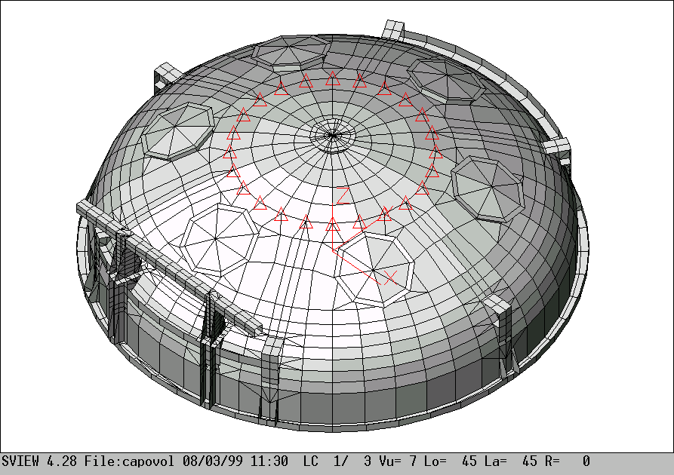

Figure 13. Belljar machining FE model.

Figure 14. Belljar machining (Z gravity): flange deformation.
In-plane deformed shape and Z displacement color scale (mm).

Figure 15. Belljar machining (Y gravity): flange deformation.
In-plane deformed shape and Z displacement color scale (mm).

Figure 16. Belljar machining (X gravity): flange deformation.
In-plane deformed shape and Z displacement color scale (mm).

- CONCLUSIONS

The deformations of the Belljar remains within functionally acceptable values and the consequent stress levels are within the material limits.

The interface points displacements require that the Belljar matching with the cell structure will be carried out by gradual offloading of the crane support and consequently closing the locking devices.

The deformations of the interface flanges of the Belljar and M1 cell still keep the sealing within its preload range, provided that the flanges planarity is achieved better than 1 mm.
For what concern the locking device interfaces the analysis suggest increasing the thickness of the cell steel web where the device head pulls up to 25 mm.

Doc_info_start
Title: Technical Report of Belljar
Document Type: Technical Report
Source: ADS International Srl
Issued by: D.Gallieni
Date_of_Issue:08-05-99
Revised by: D.Gallieni
Date_of_Revision:08-05-99
Checked by: D.Gallieni
Date_of_Check:08-05-99
Accepted by:
Date_of_Acceptance:
Released by:
Date_of_Release:
File Type: MS-WORD 7
Local Name:
Category: Aluminizing & Cleaning
Sub-Category: Aluminizing
Assembly: Aluminizing Belljar
Sub-Assembly: Technical Report
Part Name: Aluminizing Belljar structure
CAN designation:821a010
Revision:D
Doc_info_end

