Technical Report

of M1 Dummy Cell and Belljar Crab

- SCOPE OF WORK

This note reports on the design of the M1 Dummy Cell and Belljar support structures to be used during installation of the vacuum and alumination devices.
The Belljar and M1 Dummy Cell interface problem due to the finite stiffness of the two structures and their supports is addressed.
To do this, a FE analysis of the two structures vertically positioned is carried out. No mirror is modeled inside the M1 Dummy Cell. On the Belljar the mechanical pumps and their support are modeled as well.
- M1 CELL CRAB

The M1 Cell crab has been modeled according to drawing n° 822a000.
It’s completely made of steel and it presents the following geometrical-physical characteristics:

Steel mass density 7850 Kg/m³
Steel Young modulus 21e10 N/m²
CG coordinates (1622 ; 247 ; 455) mm (see fig. 1 for reference system)
Total crab mass 7780 Kg

For what concerns the M1 Cell, we have the following properties:

Steel mass density 7850 Kg/m³
Steel Young modulus 21e10 N/m²
CG coordinates (2124 ; 6 ; 4878) mm (see fig. 1 for reference system)
Total M1 Cell mass 39251 Kg

Figure n°1 reports the FE model of the M1 Cell and its support. The gravity acts in the –Z direction. The trolley structure has been modeled by beam elements and it’s constrained by four hinges corresponding to the four wheels.

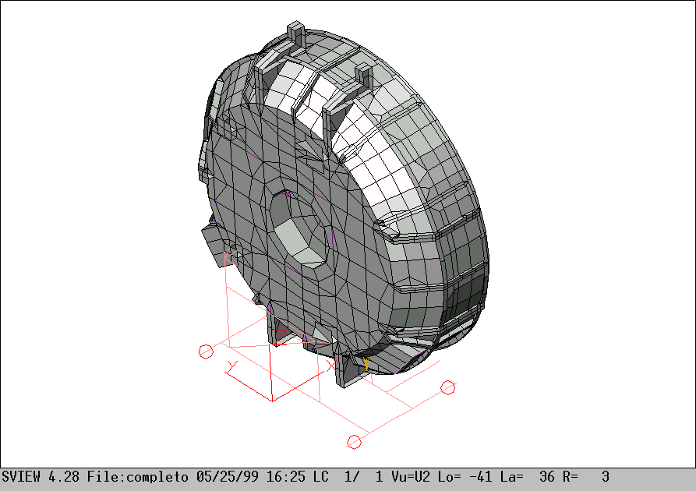

Fig. 1. The FE model used and its reference system.
The FEA results are summarized through figures 2, 3 and table 1.

Fig. 2. Deformed shape. M1 Cell top displacements – lateral view.

Fig. 3. Deformed shape. M1 Cell lateral (Y direction) displacements [mm].

As can be seen (fig. 2), the max displacements are located on the top of the M1 Cell (6.9 mm along X axis and –3.4 mm along Z axis). Looking at the system from the X direction (fig. 3), a slight rotation around X axis is evident. This is due to the not symmetrical (fig. 1) back part of the crab. The right column acts nearly in the middle of the bottom beam causing a bigger displacement respect to the one caused by the left column action.

The stress levels reached (1.4 Kg/mm²) are much smaller than the yield limit of the material used.

Hereafter, a complete displacement table is reported. It shows the main points displacements (locking devices slots A, B, E, G, H, F).

[mm] | A | B | C | D | E | F
Δx | 6.4 | 6.4 | 3.5 | 3.4 | 0.3 | 0.3
Δy | -1.5 | -1.5 | -0.8 | -0.9 | -0.1 | -0.1
Δz | -2.8 | -3.6 | -2.5 | -4.0 | -3.0 | -3.4

Table 1. Most significant displacements (see fig. 3 for conventions).

- BELLJAR CRAB

The Belljar crab has been modeled according to drawing n° 822a000. It’s completely made of steel and it presents the following geometrical-physical characteristics:

Steel mass density 7850 Kg/m³
Steel Young modulus 21e10 N/m²
CG coordinates (2152 ; 0 ;1304) mm (see fig. 5 for reference system)
Total crab mass 8400 Kg

For what concerns the Belljar, we have the following properties:

Steel mass density 7850 Kg/m³
Steel Young modulus 21e10 N/m²
CG coordinates (1165 ; 0 ; 4559) mm (see fig. 5 for reference system)
Total Belljar mass 17551 Kg (with mech. pumps’ support)
Total pump mass 2600 Kg (1300 Kg + 1300 Kg)

This analysis does not yet account for the effect of the cryo pumps and sources. In fact, their estimated mass is available but the stiffening effect of their support structure on the Belljar is at the moment unknown.
Figure n°5 reports the FE model of the Belljar and its support. The gravity acts in the –Z direction. The trolley structure has been modeled by beam and plate elements and it’s constrained by four hinges corresponding to the four wheels. The pumps’ support has been modeled by means of plate element and the pumps’ action has been reproduced by a set of lumped masses.

Fig. 4. The FE model used and the locking devices convention.

Fig. 5. Deformed shape. Belljar top displacements – lateral view.

The max displacements are located on the top of the Belljar (-4 mm along X axis and -2.6 mm along Z axis).

The reached stress levels (1.3 Kg/mm²) are much smaller than the yield stress of the material used.

The table hereafter reported shows the six locking devices displacements (A, B, E, G, H, F). The locking device symbols on the Belljar match the locking slot letter on the M1 Cell.

[mm] | A | B | C | D | E | F
Δx | -3.2 | -3.2 | -0.2 | -0.2 | -0.0 | -0.0
Δy | 0.2 | -0.2 | 1.2 | -1.2 | -0.0 | 0.0
Δz | -2.1 | -2.1 | -1.2 | -1.3 | -0.3 | -0.3

Table 2. Most significant displacements (see fig. 4 for conventions).

By means of tabs. 1 and 2, it is possible to calculate the misalignment between the locking devices and the corresponding slots. Tab. 3 reports the in-plane (Y-Z) misalignment.

[mm] | A | B | C | D | E | F
Δy | 1.7 | 1.3 | 2.0 | -0.3 | 0.1 | 0.1
Δz | 0.7 | 1.5 | 1.3 | 2.7 | 2.7 | 3.1

The maximum X direction gap between the two structures, when they are in contact in their top part, is about 11 mm. This value is within the locking devices stroke.

- CONCLUSIONS

The displacements of the interface points remains within the locking devices tolerances. The stress levels into the support structures are negligible.
The effect of the cryo pumps and sources on the Belljar deformation and attitude strongly depend on the structure that will be eventually installed to support them into the Belljar.
Such effect should be eventually compensated by shimming the lower support interfaces between the Belljar and the crab.

Doc_info_start
Title: Technical Report of M1 Cell and Belljar Crab
Document Type: Technical Report
Source: ADS Srl
Issued by: D.Gallieni
Date_of_Issue:06/01/99
Revised by:
Date_of_Revision:
Checked by:
Date_of_Check:
Accepted by:
Date_of_Acceptance:
Released by:
Date_of_Release:
File Type: MS-WORD 7
Local Name:
Category: Aluminizing & Cleaning
Sub-Category: Aluminizing
Assembly: Aluminizing Belljar Base
Sub-Assembly: Technical Report
Part Name:M1 Cell and Belljar Crab
CAN designation:822a005
Revision:B
Doc_info_end

