Technical Report

of M1 Covering System

SCOPE OF WORK

This document reports on the M1 covering system mechanical design and structural analysis.

The mechanism concept hereafter analyzed has been already proofed on a reduced scale prototype.

The most relevant structural verification and a FEA of the bellow are reported for the full scale system.

The worst case operation, given by the telescope pointing at horizon, is addressed as well. Such maneuver could occur in case of emergency during telescope observing time.

INTRODUCTION

The major components of the M1 Covering System are the deployment swing arm and the circular bellow fabric cover.

The reference drawing is 727a007.

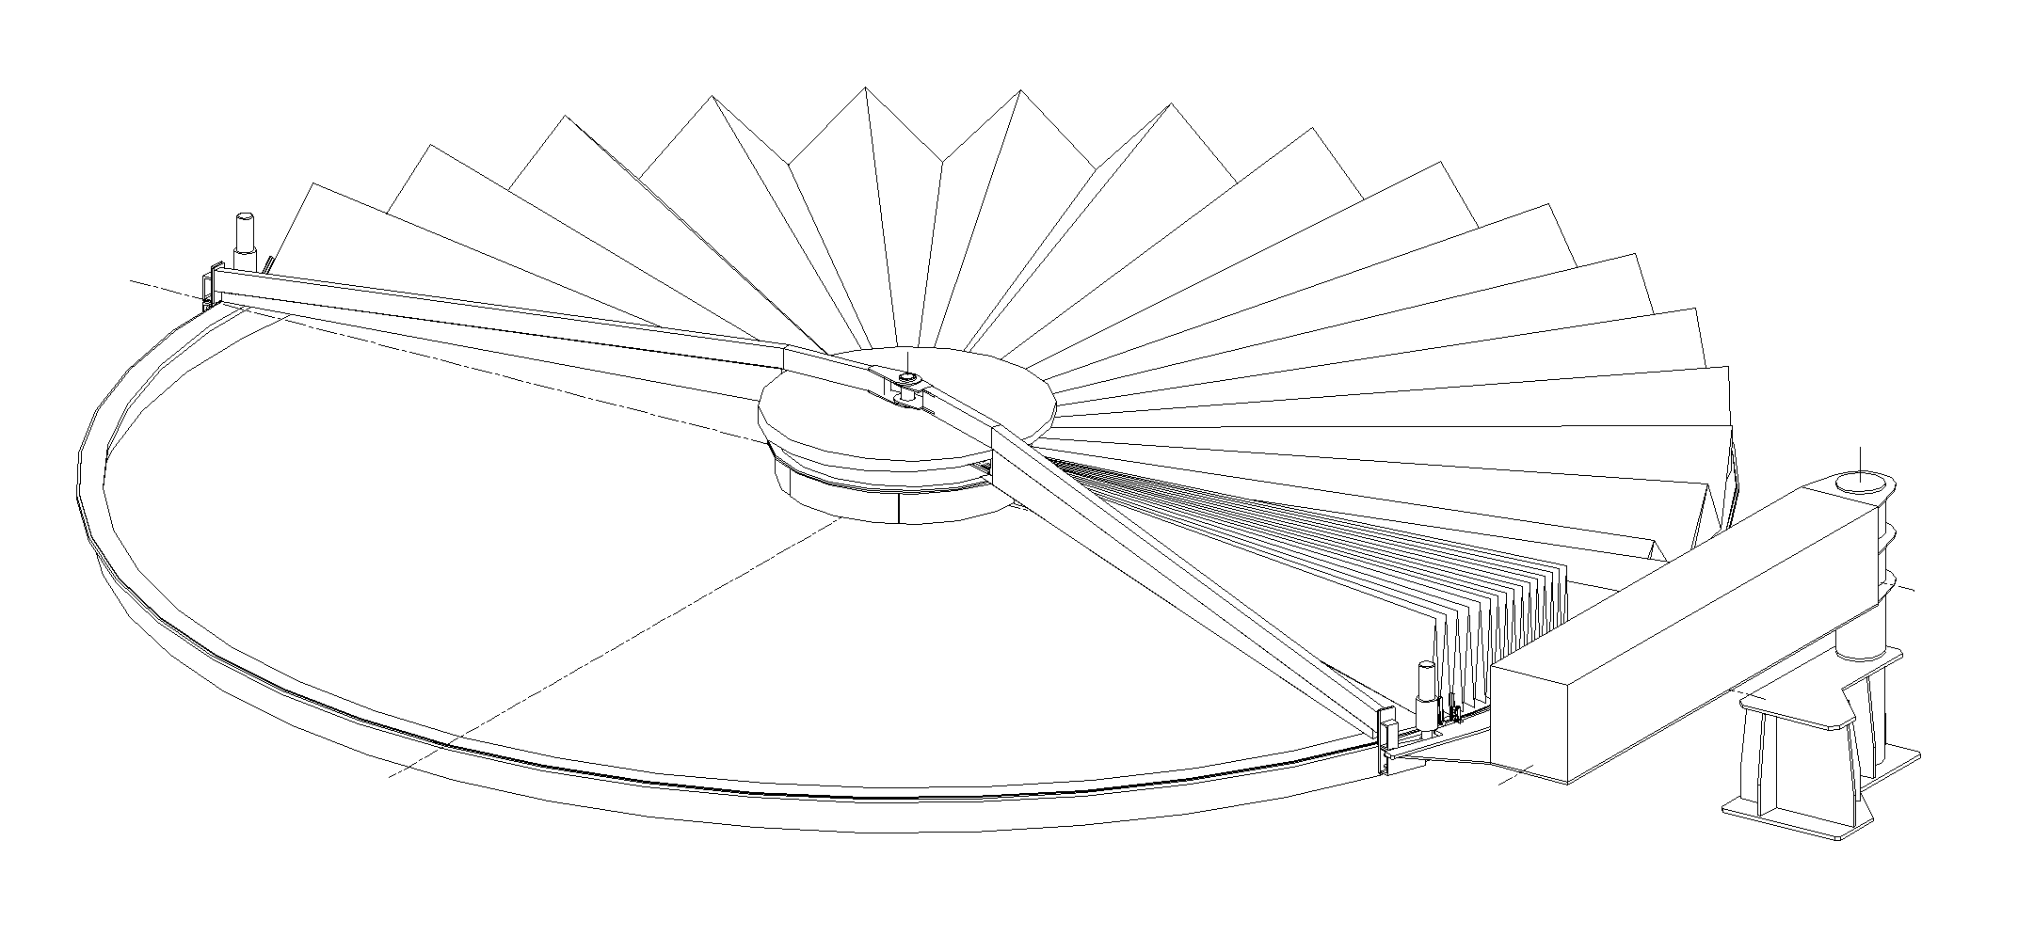
Figure 1. M1 Covering System.

The cover bellow is made by two independent sets of 32 stainless steel 1 mm thick blades.
Each blade runs on two rails, a shorter one at the end of the boom over the mirror center and the outer support made over the M1 cell edge.
The two 180 deg bellow sections are independently driven by two DC motors that run on a chain fixed to the M1 cell outer edge.

The swing arm retracts the mirror cover from the M1 cell obstruction during telescope operation.
The arm is operated by a screw jack coupled to a standard AC motor.

The two mechanical systems are verified for vertical operation (telescope horizon pointing).

STRUCTURAL VERIFICATIONS

The structure holding the bellow is verified under the loading produced when the bellows are folded and the boom is deployed with telescope at zenith pointing.

The c.o.g. of the mirror cover boom with the cover completely folded is 2500 mm inside the swing arm hinge and the total mass of the movable part is about 1500 Kg.

The boom is a tapered beam having the max cross section 460mm wide (6 mm thick) and 488 mm high (5 mm thick).

The bending moment is 15 kN x 2,5 m = 37,5 kNm. The section moment of inertia is 0,416x10⁻³ m⁴.

Thus, the max bending stress at the boom root results equal to 2,2x10⁷ Pa.

The smallest section at the boom tip is 85 mm wide (6 mm thick) and 200 mm high (5 mm thick).
Its moment of inertia is equal to 0,017x10⁻³ m⁴.

To compute the tapered beam deflection we assume an average moment of inertia equal to 0,216x10⁻³ m⁴ and a 15000 N load applied at the boom tip (5 m aperture).

The resulting tip deflection is 5,3 mm.

Another contribution to the bellow center support deflection under gravity loading is the torsion of the swing arm portion between the hinge and the boom root.

The section of the swing arm is constant: 500 mm width by 488 mm high, with constant wall thickness of 6 mm.

The torsional moment applied to such beam is 37,5 kNm and the beam length is 1,7 m.

The torsional inertia of the section is equal to 0,70x10⁻³ m⁴ and then the resulting twist angle is 1,15 mrad.

Such twist of the swing arm add further 5,8 mm to the boom tip deflection.

Thus, the bellow center moves by 11,1 mm downward because of its own weight when the system is deployed over the M1 with the telescope at zenith pointing.

Such deformation should not stuck the bellows supports on the external rail during the folding/unfolding maneuver.

SWING ARM DRIVE UNIT

The first operation to deploy the mirror cover is the 90 deg rotation of the swing arm.

The c.o.g. of the mirror cover boom with the cover completely folded is 2500 mm inside the swing arm hinge and the total mass of the movable part is about 1500 Kg.
The screw jack distance from the swing arm hinge is 375 mm.

Thus, the maximum pulling force on the screw jack when lifting the swing arm is equal to 100 kN.

The selected screw jack is UNIMEC 559 (1:30) coupled with a standard AC motor type 112 – 4 kW – 1500 rev / 1’.

The screw lead is 9 mm and the overall screw jack efficiency is 0,17.

The screw jack output linear velocity is 1450 / 30 x 9= 0.435 m / min.
The demanded power is (0.435 x 100000 / 9.81) / (6120 x 0.17) = 4.26 kW.

The torque at the worm gearbox slow shaft is $\frac{\text{4000}×0,\text{80}}{2π×\frac{\text{1500}}{\text{60}}}×\text{30}$ = 611 Nm.

The force is then $\text{611}×\frac{2π×0,\text{17}}{0,\text{009}}$ = 72,5 kN.

Despite the 4 kW motor seems not sufficient to lift the cover in emergency conditions, it is accepted because it is rated for continuous service while its actually used for few minutes. This should allow also compensating for any derating due to the altitude.

BELLOWS DRIVES

The second step to close the mirror cover is the unfolding of the two independent bellows.

The tangential force along the M1 cell edge needed to unfold each bellow is computed to verify DC motors sizing.

The c.o.g. of an unfolded sector α is at $\frac{2}{3}R×\frac{\text{sin}α}{α}$ from the mirror center along the sector median.

Being M the total mass of the mirror cover (360 deg) the mass of the sector α is goven by: $M×g×\frac{α}{π}$.

The moment arond the mirror center of the sector weight is
$M×g×\frac{α}{π}×\text{sin}\frac{α}{2}×\frac{2}{3}R×\frac{\text{sin}α}{α}$.

Thus, the tangential force requested to the drive system is:

F_{T} = $\frac{2}{3 π}×M×g×\text{sin}α×\text{sin}\frac{α}{2}$ and the maximum is F_{Tmax} = $\frac{2}{3 π}×M×g×0,\text{77}$.

The cover total mass is about 800 Kg and the max force at the pinion / chain coupling is 1300 N.

Moreover, the own weight of each rotating arm and motor about 900 N, then adding 450 N to the max force required at the pinion teeth of the driving system.

The selected motor is a WACO RS-500-BT with 2.0 Nm nominal torque gives at the pinion teeth a tangential force equal to:

F_{T}’ = (2 x 120 x 0.6) / 0.055 = 2618 N

where 120 is the reduction ratio of the planetary gearbox PLC 120 coupled to the DC motor and 0,6 is the overall efficiency of the driving unit.

Thus, the available force seems suffice for the bellow unfolding even in vertical position. Actually, the above reported budget does not include yet the friction effect given by the numerous hinges connecting the bellow blades.

BELLOW STRUCTURAL ANALYSIS

The structural properties of the bellow itself clearly depends on the angle formed by its sectors when it reaches the deployed condition, that is the less stiff configuration.

The bellow structural analysis is then run on a reduced model made of four contiguous sectors hinged together.

The inner and outer edges of each sector are simply supported, the sectors common edges are hinged together and the free edges of the two lateral sectors are restrained along tangential direction for symmetry.

Each sector is a 1 mm thick stainless steel plate and its mass is 9.4 Kg.

The static analysis is run by applying 1g gravity loading with telescope at zenith pointing.
An additional load of 3000 N is distributed over the bellow on a 1m x 2m inset from the outer edge. This condition can occur for servicing the derotators area.

The max vertical (i.e. telescope optical axis) deformation is 3.1 mm

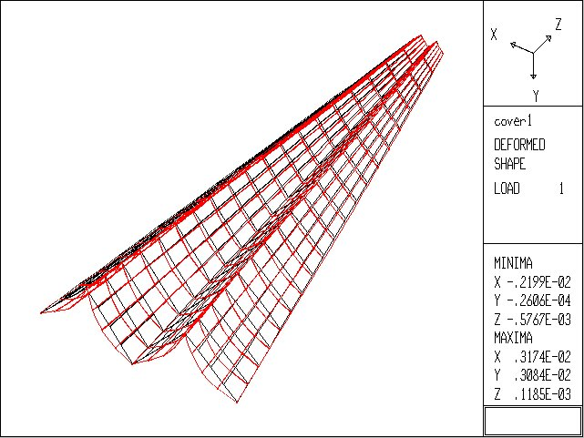
Figure 2. Fabric cover static analysis.

Each bellow blade is terminated on the outer rail with a reaction arm that limit the max aperture of the blade itself.

The max bending load on such reaction arm is checked for the above mentioned load condition, that is when servicing to the derotators area requires that distributed load must be withstand by the cover.

We assumed that the load spreader carrying 3000 N max MUST ALWAYS rest on at list FOUR blades pairs.
In such configuration the roller of the reaction arm that runs below the cell edge would withstand 4500 N shear load.

The limit to the bellow loading is then given by the reaction arm capability to limit the blades rotation.

The modal analysis confirms that when deployed and supported along the inner and outer perimeters the cover is a rigid structure.

Mode number | Frequency [Hz]
1 | 5.7
2 | 7.8
3 | 8.1
4 | 8.8
Table 1. Fabric cover slice natural frequencies.

Figure 3. Fabric cover modal analysis.

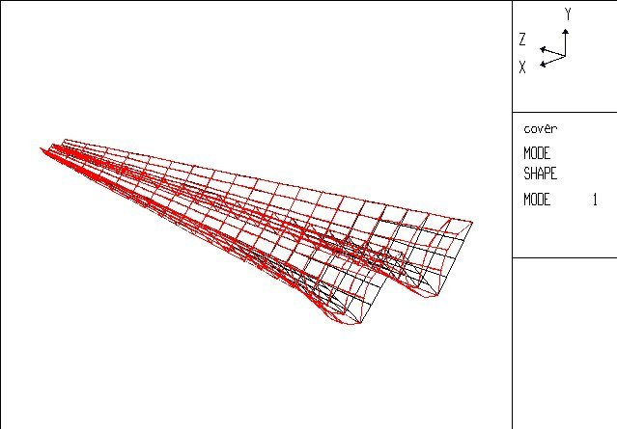
Thus, both static and dynamic analysis results seems compatible with the mirror cover operation.

CONCLUSIONS

The mirror covering system proofed on a scaled model appears to be applicable to the actual M1 cells even in the most demanding operational condition, that is emergency closing with telescope at horizon pointing elevation.

Doc_info_start
Title: Technical Report of M1Covering system
Document Type: Technical Report
Source: ADS International Srl
Issued by: Gallieni
Date_of_Issue:07/13/01
Revised by: Gallieni
Date_of_Revision:07/13/01
Checked by:Gallieni
Date_of_Check:07/13/01
Accepted by:
Date_of_Acceptance:
Released by:
Date_of_Release:
File Type: MS-WORD 7
Local Name:
Category: M1
Sub-Category: M1 Cell
Assembly: M1 Mirror Cover
Sub-Assembly: Technical Report of M1 Covering System
Part Name:
CAN designation:727a010
Revision:C
Doc_info_end

