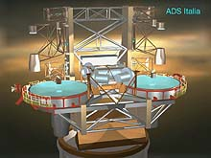
LBT PROJECT
2x8,4m TELESCOPE
Doc.No. : 645s020
Issue : b
Date : 20-Feb-2006

LBT PROJECT

2 X 8,4m OPTICAL TELESCOPE

Metallic coating specification
of the convex (‘actuator’) side
of LBT Adaptive Secondary thin shell

 | Signature | Date
Prepared | Guido Brusa | Feb 20, 2006
Reviewed | John Hill | Feb 20, 2006
Approved | John Hill | Feb 20, 2006

- Revision History

Issue | Date | Changes | Responsible
a | 17-Feb-06 | First version | Guido Brusa
b | 20-Feb-06 | Adhesion sentence added in Sec. 5 | Guido Brusa

- Table Of Contents

1. Revision History 2
2. Table Of Contents 2
3. List Of Abbreviations 2
4. About this document 3
4.1. Purpose 3
4.2. Applicable Documents 3
5. Coating specification 4
5.1. Geometry of the circular areas 5
5.2. Geometry of the division lines 5
5.2.1. Set B of lines 6

- List Of Abbreviations
Symbols | Description
RoC | Radius of curvature

- About this document

This document specifies the geometry and type of metallization that is used for the convex (‘actuator’) side of the LBT adaptive secondary thin shell.

  - Purpose

The goal of this document is to provide the general information about the metallic coating. The exact dimensions for the geometry of the metallic deposition is available thru drawing [AD1] in which are also reported the tolerances.

  - Applicable Documents

[AD1] 645s011- “Deformable Mirror Shell for LBT672, Convex Side Shell Aluminum Pattern”

[AD2] 640a006- “ADAPTIVE SECONDARY CONTROL SYSTEM DESIGN REPORT”

[AD3] 640a005- “f/15 ADAPTIVE SECONDARY MECHANICAL DESIGN”

- Coating specification

The convex side (or actuator side) of the LBT thin shell has to have a metallic coating to provide a 'common' armature for electrical purposes. In particular this armature is connected to the reference signal of the position capacitive sensor in the scheme used for the control of the thin shell shape [AD2].
For this metallic layer, a vacuum deposited layer of aluminum has been chosen. Its thickness should be 90 nm (+/- 5 nm) and the aluminum layer should not be protected. A good adhesion of the aluminum layer to the shell should be achieved.
The geometry of the deposited layer is shown in Fig.1 (it is important to mention that this view is ‘mirrored’ with respect to the one shown in [AD2]). The surface is completely covered with aluminum with the exception of:
- 672 circular areas of an approximate diameter of 10mm;
- six division lines (of an approximate width of 2mm).

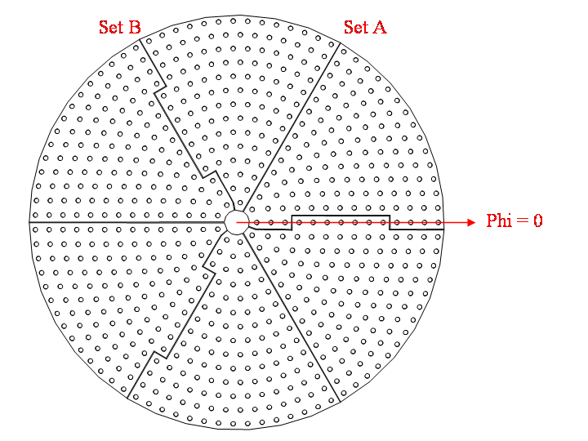
Figure 1 - In this figure the location of the circular areas and the two set of division lines (A and B) are shown. It is important to notice that this view is looking from the convex side toward the center of the reference sphere.
The six lines allow for six independent reference armatures [AD2]. The circular areas provide inspection 'windows' for the glue pads used to bond 672 magnets to the shell surface.

  - Geometry of the circular areas

We consider the nominal surface of the convex side of the shell, i.e. a spherical cap of diameter 911mm and RoC 1995mm [AD3]. We set a spherical coordinate system with center in the center of the sphere and axis of theta=0 passing thru the center of the shell. The nominal location of the centers of the circular areas can be obtained by intersecting the spherical surface with axes at fixed thetas and uniformly distributed in phi. There are 14 different values of theta (or 14 rings) each one with a different number of areas. Tab1 (extracted from [AD3]) reports the angles and number of areas per ring.
Each area must be located in phi as well as theta and this is done by arbitrarily selecting the phi=0 plane and clocking all the rings to start at phi=0 (see Fig.1).

Actuator row | # of actuators | Angle from optical axis  (decimal degrees)
1 | 9 | 1.2615
2 | 15 | 2.1498
3 | 21 | 3.0382
4 | 27 | 3.9266
5 | 33 | 4.8150
6 | 39 | 5.7034
7 | 45 | 6.5918
8 | 51 | 7.4802
9 | 57 | 8.3686
10 | 63 | 9.2570
11 | 69 | 10.1454
12 | 75 | 11.0338
13 | 81 | 11.9222
14 | 87 | 12.8105
Table 1- Table defining the geometry of the areas. First column is the row (or ring) number. Second column reports the number of areas per ring. The third column reports the theta angle from the axis of the shell.

  - Geometry of the division lines
The division lines are six arranged in two sets (call it A and B) of three identical lines rotated by 120 deg around the theta=0 axis. The set A is simply obtained by intersecting the spherical surface with a plane passing thru the theta=0 axis and at phi=60, 180, 300 degrees. The set B is more complicated and will be described below.
Before discussing how the second type of lines can be constructed it is important to remind that any line that divides the aluminum coating in six areas in the way shown in Fig.1 is acceptable provided that none of these lines overlap with any circular areas having the centers described in the previous paragraph and of a diameter of 25mm. This requirement is due to the need of having the set of 672 armatures present on the reference body to be fully covered by the reference armatures.
    - Set B of lines
A possible way of constructing set B of lines is here described for the case around phi=0 (see Fig.2). Construct the points on the spherical surface that are half way (along the spherical surface) between the first set of centers (phi=0) and the second set with phi=360/n[i], where n is the number of areas for ring i (see Tab.1, second column). Include in this set the center of the shell. Interpolate (in the minimum length sense) a line (call it line2) that connects all these points and start at inner edge of the shell and ends at the outer edge. Construct a symmetric version of the previous line obtained by reflection around the plane phi=0. Call this line line1. Build a maximum circle that runs thru a point half way between rings 3 and 4 (see Fig.2) at phi=0 and intersects the plane phi=0 at right angle. Call this circle circle1. Build a second maximum circle between ring 10 and 11 in the same way and call it circle2. The division line is built in the following way:
- follow line1 starting at the inner edge of the shell until this intersects circle1;
- follow circle1 until it intersects line2;
- follow line2 until it intersects circle2;
- follow circle2 until it intersect line1 again;
- follow line1 until the outer edge of the shell is reached.

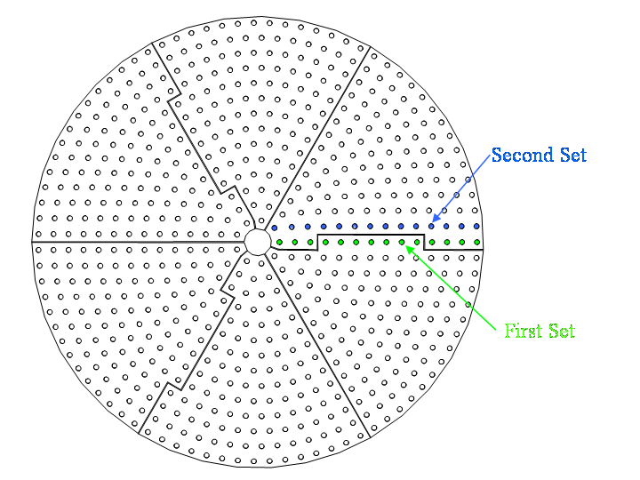
Figure 2 -This figure shows the two sets of areas with which division lines of type B can be defined.

--oOo--

Doc_info_start
Title: Metallic coating specification of the convex (‘actuator’) side of LBT Adaptive Secondary thin shell
Document Type: Specification
Source: Steward Observatory
Issued by: Guido Brusa
Date_of_Issue: Feb 20, 2006
Revised by:
Date_of_Revision:
Checked by:
Date_of_Check:
Accepted by:
Date_of_Acceptance:
Released by:
Date_of_Release:
File Type: MS Word
Local Name: Metallic coating specification of the convex (‘actuator’) side of LBT Adaptive Secondary thin shell
Category: Telescope Auxiliaries (600)
Sub-Category: M2 Adaptive F/15 (640)
Assembly: M2 Adaptive F/15 Optical (645)
Sub-Assembly:
Part Name:
CAN Designation: 645s020b.doc
Revision: b
Doc_info_end

Some of the angle values show some rounding error in the last digit. See drawing AD1 for the exact values.

