Technical Report

of Spider M3

- SCOPE OF WORK

This document reports on the M3 spider structural analysis.

The model behavior has been studied from the static and the dynamic point of view, in two different configurations: the spider truss alone and the whole spider, including the rotation mechanism.

- SPIDER TRUSS ANALYSYS

Model

The finite element model has been developed in accordance with the technical specification 401a005.

The material for both the spider and for the hub structure is steel:

- mass density: 7850 kg/m³
- Poisson ratio: 0.3
- thermal coeff.: 16 e⁻⁶ 1/K
- Young mod.: 21 e¹⁰ N/m².

The estimated mass of the M3 hub dummy is 240 Kg.

The overall weight is 18650 N. A further concentrated mass of 100 Kg is added to the deployment mechanism (fig. 1: label M).

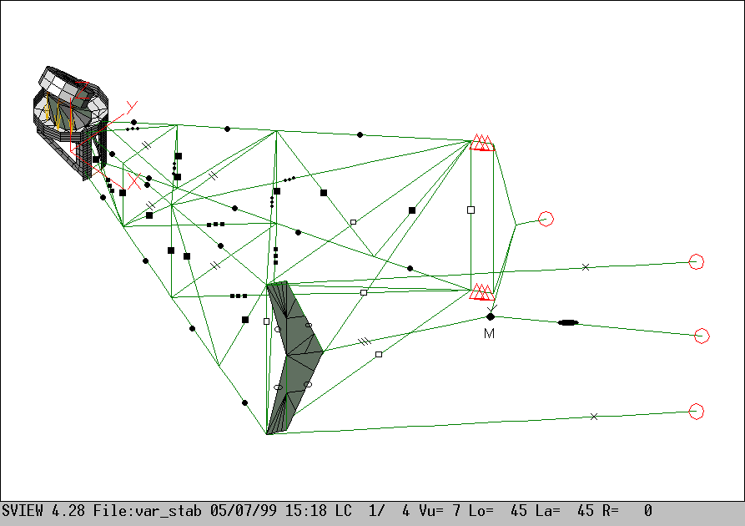

Fig. 1. The M3 spider FE Model and its beam’s groups.

Hereafter, with reference to fig. 1, the beam’s sections table is reported:

Beam’s symbol | A [m²] | I_{x} [m⁴] | I_{y} [m⁴] | J [m⁴] | Shape [mm]
• | 1.47 x10⁻³ | 2.75 x10⁻⁷ | 2.32 x10⁻⁶ | 6.11 x10⁻⁷ | (  ) 65x35x4 (2)
■ | 7.36 x10⁻⁴ | 1.38 x10⁻⁷ | 3.84 x10⁻⁷ | 3.11 x10⁻⁷ | (  ) 65x35x4
□ | 3.49 x10⁻³ | 5.41 x10⁻⁶ | 5.41 x10⁻⁶ | 1.08 x10⁻⁵ | Φ 121 th. 10
••• | 1.20 x10⁻⁴ | 1.60 x10⁻¹⁰ | 9.00 x10⁻⁹ | 6.00 x10⁻¹⁰ | 30x4
 | 2.40 x10⁻⁴ | 3.20 x10⁻¹⁰ | 7.20 x10⁻⁸ | 1.29 x10⁻⁹ | 60x4
|| | 3.54 x10⁻⁴ | 2.10 x10⁻⁸ | 8.26 x10⁻⁸ | 5.18 x10⁻⁸ | (  ) 45x20x3
X | 3.84 x10⁻³ | 1.18 x10⁻⁶ | 1.18 x10⁻⁶ | 2.36 x10⁻⁶ | Φ 70
O | 1.20 x10⁻³ | 1.44 x10⁻⁶ | 1.00 x10⁻⁸ | 4.00 x10⁻⁸ | 120x10
||| | 4.46 x10⁻³ | 3.53 x10⁻⁵ | 2.89 x10⁻⁶ | 1.49 x10⁻⁷ | ( I ) 120x236x10
 | 5.29 x10⁻³ | 7.38 x10⁻⁵ | 2.90 x10⁻⁶ | 1.76 x10⁻⁷ | ( I ) 120x319x10
✓ | 2.12 x10⁻³ | 3.58 x10⁻⁷ | 3.58 x10⁻⁷ | 7.18 x10⁻⁶ | Φ 52

Table 1. Beam’s sections (ref. figure 1 for the coordinate system definition).

A pre-load is applied to the spider crosses to increase their bending stiffness. It is well approximated by imposing a negative temperature gradient (-6.21 C for the longest tie rods) between the specified beams (•••;) and the rest of the structure (T_{ref}=0°).
In fact it has been verified that the thermal deformations are almost totally absorbed by the cross tie rods.

The pre-load value (5000 N for the longest bottom tie rods) comes from a static-dynamic compromise that intends to increase the natural frequencies of the cross tie rods without affecting static performances.

The pre-load values for the lower tie rods is, from bay no. 1 to bay no. 3 respectively , 2500 N - 5000 N and 5000 N. The pre-load for the upper tie rods is exactly a half of the previous values.

Moreover, given the final hub mass distribution, the spider torsion in the 1st bay (the one closest to the hub interface) can be controlled by tuning the pre-load of the two cross tie rods in that bay.

Results

The max vertical deflection of the spider at the hub interface is 0.18 mm when the telescope is pointing the zenith.
In this condition the hub rotations are Rx = -7.3” and Ry = -8.7”.

The dynamic analysis is run including the load stiffening effect of the truss elements.

The first global natural frequency, that is a torsional-lateral mode, results at 31.59 Hz, while the lowest frequency of 12.4 Hz is the bending of the largest cross tie rods.

- SPIDER AND ROTATION MECHANISM

Model

The complete model of the spider includes the rotation mechanism. The deployment roller screw rod is preloaded to account for the Belleville springs compression occurring when the actuator reaches the limit switches.

The 25 kN pre-load is modeled by imposing a positive temperature gradient equal to 5.8 °C between the specified beams (✓) and the rest of the structure (T_{ref}=0°).

The temperature gradient is computed by equalizing the beam elongation due to the imposed pre-load and the thermal expansion. This temperature pre-load is then applied both to the static and modal analysis.

Results

The static analysis gives a max vertical deflection equal to 0.26 mm, 0.08 mm larger than the own spider truss one.

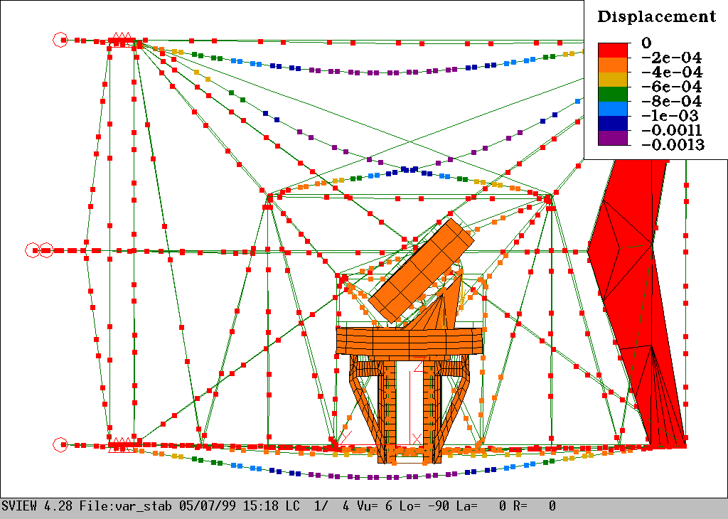

Fig. 2. Spider static analysis: displacements at zenith pointing [m].

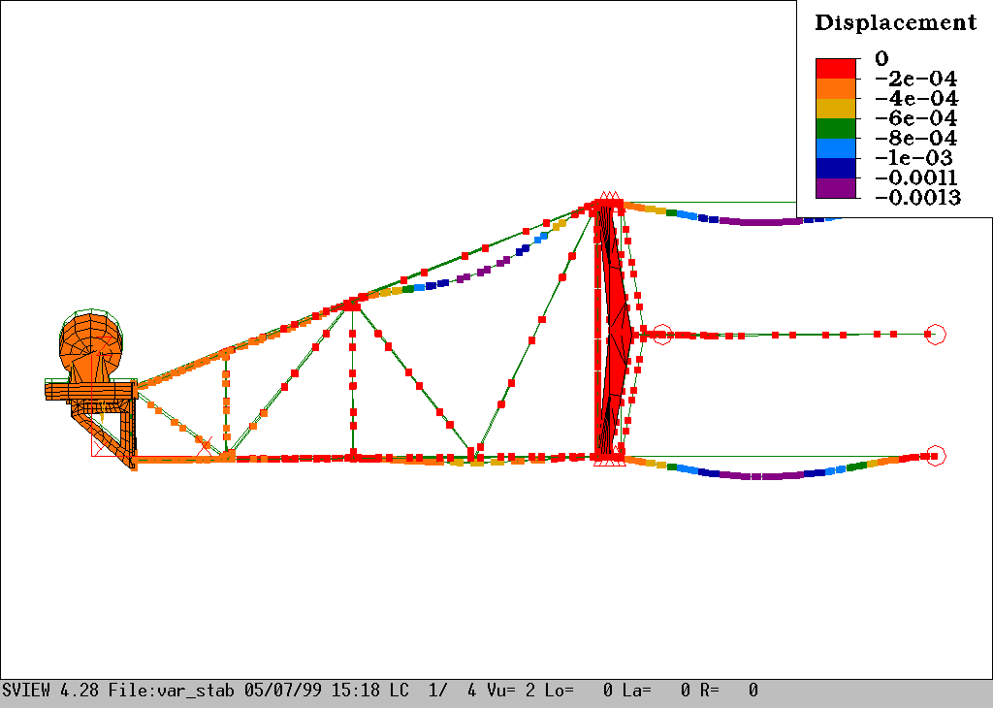

Fig. 3. Spider static analysis: displacements at zenith pointing [m].

Hereafter a complete displacement table is reported. Displacements and rotations are measured at the hub interface with the spider.

Elev. [deg] | Δ_{x} [m] | Δ_{y} [m] | Δ_{z} [m] | R_{x} [asec] | R_{y} [asec] | R_{z} [asec]
90 | 5.26 10⁻⁵ | 2.65 10⁻⁵ | -2.55 10⁻⁴ | 4.03 | -10.85 | -2.74
60 | 7.59 10⁻⁵ | -1.76 10⁻⁵ | -2.39 10⁻⁴ | 1.52 | -8.51 | 1.20
30 | 8.23 10⁻⁵ | -5.10 10⁻⁵ | -1.60 10⁻⁴ | -4.88 | -4.18 | 4.05
0 | 6.99 10⁻⁵ | -6.49 10⁻⁵ | -4.00 10⁻⁵ | -13.15 | 0.84 | 4.39

Table 2. Hub–spider interface displacements and rotations.

As can be seen, when the telescope is pointing the zenith, the R_{X} rotation absolute value for the whole system is smaller than the one of the truss alone. In fact, when the truss is ideally constrained the R_{X} positive rotation due to the gravity load is smaller than in the real case and the dominant effect is given by the cross tie rods pre-load.

The stress levels in the truss, are always well within the operative range of the material used.
The modal analysis shows a first global mode at 26.62 Hz (fig. 5).
Mode no. 12 is mainly a local mode for one of the tip’s tie rods and it involves a slight torsional vibration on the payload (figure 4). Since the displacements induced on the payload are more than an order of magnitude smaller than the beam’s one, we can consider this a local effect.

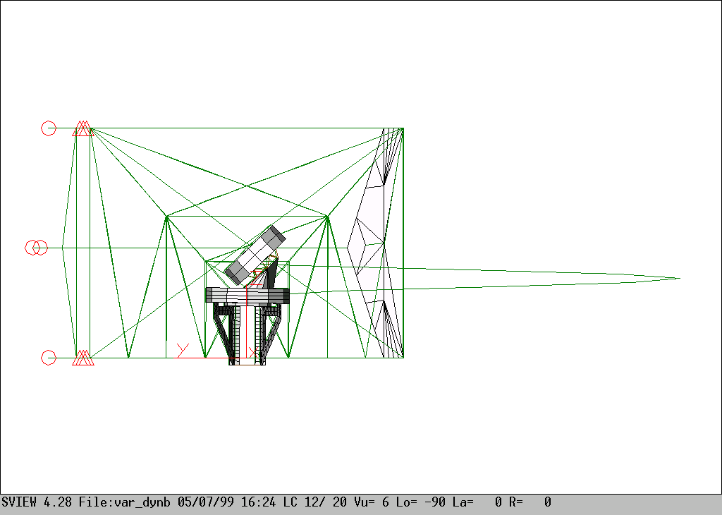
Fig. 4. Spider modal analysis: mode no. 12 (23.9 Hz).

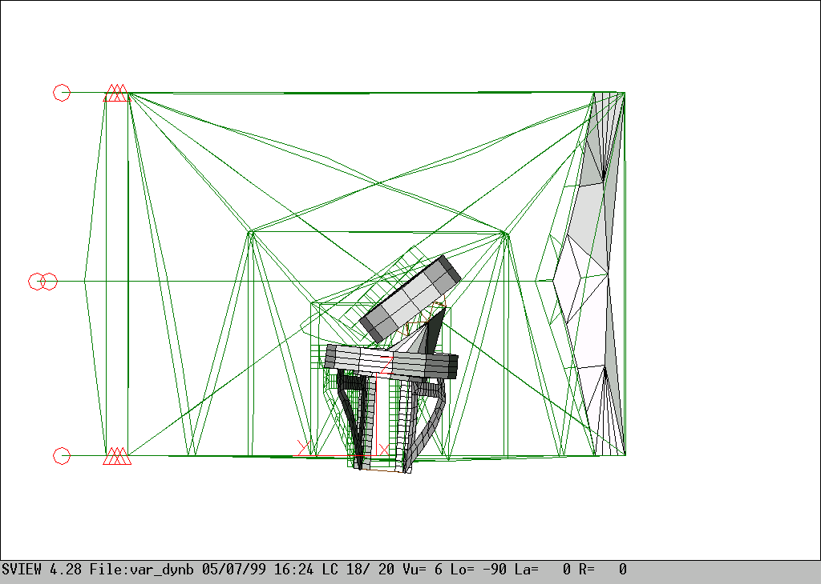
Fig. 5. Spider modal analysis: mode no. 18 (26.6 Hz).

Mode number | Frequency [Hz] | Description
1 | 7.10 | Local bending: rear guiding beams
2 | 7.11 | Local bending: rear guiding beams
3 | 9.53 | Local bending: 2nd bay tie rod
4 | 9.94 | Local bending: 2nd bay tie rod
5 | 12.75 | Local bending: 3rd bay tie rods
6 | 12.80 | Local bending: 3rd bay tie rods
7 | 13.06 | Local bending: 3rd bay tie rods
8 | 13.20 | Local bending: 3rd bay tie rods
9 | 15.57 | Local bending: rear guiding beams
10 | 15.71 | Local bending: rear guiding beams
11 | 17.52 | Local bending: 3rd bay tie rods
12 | 23.89 | Local bending: 1st bay tie rod
13 | 24.46 | Local bending: 2nd bay tie rod
14 | 24.54 | Local bending: 2nd bay tie rod
15 | 25.51 | Local bending: 1st bay tie rod
16 | 26.12 | Local bending: 3rd bay tie rods
17 | 26.16 | Local bending: 3rd bay tie rods
18 | 26.63 | Global mode (torsional + lateral)

Table 3. Spider natural frequencies.

- CONCLUSIONS

The structural analysis of the M3 spider validates the design that originated the technical specification 401a005.

Doc_info_start
Title: Technical Report of M3 unit
Document Type: Technical Report of Spider M3
Source: ADS Srl
Issued by: D.Gallieni
Date_of_Issue:05-07-99
Revised by: D.Gallieni
Date_of_Revision:
Checked by:
Date_of_Check:
Accepted by:
Date_of_Acceptance:
Released by:
Date_of_Release:
File Type: MS-WORD 7
Local Name:
Category: Telescope elevation mount
Sub-Category: Swing Arms
Assembly: Technical Documentation
Sub-Assembly: Technical Report of spider M3
Part Name:
CAN designation:545a003
Revision:C
Doc_info_end

