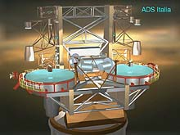
LBT PROJECT
2x8.4m TELESCOPE
Doc.No. : 665s010
Issue : F
Date : 26 October 2006

LBT PROJECT

2 X 8.4m OPTICAL TELESCOPE

Technical Specifications: Generating, Polishing, and Testing of LBT Tertiary (M3) Mirrors

 | Signature | Date
Prepared | Oli Durney | December 15, 2005
Reviewed | John Hill, Joar Brynnel, Guido Brusa, Daniele Gallieni, Phil Hinz | December 15, 2005
Approved | John Hill | October 26, 2006

- Revision History

Issue | Date | Changes | Responsible
A | 18 Nov 2005 | First draft | Oli Durney
B | 01 Dec 2005 | Shipping risks, micro-roughness spec, test setup | Oli Durney
C | 08 Dec 2005 | Break up report into RFP and Tech Spec, define polishing procedure, print-through | Oli Durney
D | 15 Dec 2005 | John Hill corrections/suggestions | Oli Durney
E | 07 Aug 2006 | Minor clarifications | John Hill
F | 26 Oct 2006 | Changes to facilitate manufacturing | Robert Meeks

- Table Of Contents

1. REVISION HISTORY 2

2. TABLE OF CONTENTS 3

3. SCOPE OF WORK 4

4. INTRODUCTION 4

5. SUBSTRATE 5
5.1. Back Surface Treatment - Parallelism 5
5.2. Edge Surface Finish - Centration 5
5.3 Surface Defect (Blank #1) 5

6. OPTICAL SURFACE SPECIFICATIONS 6
6.1. Optical Clear Aperture 6
6.2. Power 6
6.3. Astigmatism 6
6.4. Higher-Order Figure Irregularity 7
6.5. Measurement Errors 7
6.6. Surface Finish 7
6.7. Cosmetic Quality 7
6.8. “Print-through” 8

7. APPENDIX 9

8. REFERENCES 11

- Scope of Work

This document reports the generating and polishing specification for the tertiary mirrors (M3) for the Large Binocular Telescope (LBT).

- Introduction

The technical specifications for generating, polishing, and testing two (2) 640x540 mm, flat, honeycomb mirrors to be used as the tertiary mirrors for the Large Binocular Telescope (LBT) located on Mt. Graham, Arizona, USA follows. The mirror blanks will be supplied by the LBT Corporation and are currently in storage at Steward Observatory on the University of Arizona campus in Tucson.

- Substrate

The mirror blanks are a honeycomb structure fabricated by HexTek in Tucson, Arizona, USA. They use 15 mm thick front and back glass plates and an interposed honeycomb structure. Separation between front and back plates is 97 mm (between mean plates). Rib thickness is 6 mm and outermost wall thickness is 3 mm. The substrate material is Schott Borofloat glass. The calculated mass of the substrate is 27.1 kg (59.6 lbs). The general shapes of the mirrors are ellipsoidal octagons with a major axis diameter of 640 mm and minor axis diameter of 540 mm. The mirror blanks are in the un-generated form supplied by HexTek. See photo and drawings in Appendix.

  - Back Surface Treatment - Parallelism

The back surface will be machined to a parallelism tolerance of +/- 100 microns (+/- 64.46 arcsec, major axis) with respect to the polished front surface. A minimum of 12 mm glass plate thickness shall be maintained during the flat generation process. No more than 3 mm of material will be removed.

The back surface shall be fine ground with 400 or finer grit wheel. The back surface has a series of access holes drilled through the plate for each of the honeycomb pockets.

  - Edge Surface Finish - Centration

The edge surfaces of the front and back plates of the mirror blanks were not machined. They must be fine ground with a 400 or finer grit wheel and should be co-planar to each other to +/- 250 microns. All edges shall be hand-beveled at a 45 degree angle (+/- 15 degrees) to a face width of 0.25 mm to reduce the risk of chipping. Total front and back plate dimensions shall be greater than 638x538 mm after edge surface machining. No more than 2 mm of material shall be removed

  - Surface Defect (Blank #1)

A small ‘defect’ in one of the corners of Blank #1 is present. The honeycomb mirrors are fabricated using a technology called Gas-FusionTM in which the top and bottom glass plates are bonded to the interposed honeycomb structure. A small 10x10mm area near one of the corners of the top glass plate did not fused properly and created a void. The location is marked on the blank. Suitable protection to the affected area must be provided during generating and polishing.

- Optical Surface Specifications

The M3 tertiary flat mirrors will use a conventional rms wavefront error that is tabulated in Table 1.

The manufacturing figure error specifications consist of two parts: known manufacturing errors and measurement errors. The manufacturing errors consist separately of curvature, astigmatism, and the sum of all other higher-order surface figure errors.

The measurement of the figure errors should be taken so as to sample efficiently spatial scales between 50 mm and 360 mm on the tertiary surface. Testing may be performed in any orientation (horizontal, vertical, inclined) and angle of incidence that enables the requirements of this specification to be verified.

Test Aperture Diameter [mm] | Allowable Surface Error [nm rms] | Allowable Wavefront Error [nm rms]
360 | 20 | 40
150 | 12 | 24
50 | 5 | 10
Table 1: Pseudo-Structure Function (with Power and Astigmatism removed)

  - Optical Clear Aperture

The requirements Table 1, Sections 6.2, 6.3, 6.4, 6.5, 6.6, 6.7, and 6.8 shall apply within an ellipse with major axis diameter of 635 mm and minor axis diameter of 535 mm. A 5 mm wide zone around the perimeter of the elongated octagon shall also be polished to the surface roughness requirements of Section 6.6 but shall not be required to meet the specifications of Table 1, Sections 6.2, 6.3, 6.4, 6.5, 6.7, or 6.8.

  - Power

The radius of curvature of the best fit sphere shall be 50 km or greater (1 μm surface sag at 320 mm radius).

  - Astigmatism

The astigmatism in the best-fit surface shall be less than 200 nm rms (450 nm peak-to-valley) surface error measured over the optical clear aperture.

  - Higher-Order Figure Irregularity

The surface figure errors (excluding the best fit sphere and astigmatism errors) are measured as a function of sub-aperture diameter and shall be no greater than that shown in Table 1. Values for each sub-aperture are to be evaluated after the removal of a global (over the optical clear aperture) fit of power and astigmatism limited to the values specified above. For sub-apertures smaller than the optical clear aperture, the figure error shall be defined as the rms surface error averaged over a number of representative sub-apertures that cover the entire area of the optical clear aperture.

  - Measurement Errors

Uncertainty in the measurement of manufacturing errors for a given sub-aperture size shall be no greater than one-half of the manufacturing irregularity error shown in Table 1. Deflections due to the mirror support may be excluded from the calculation of measurement uncertainty but vendor shall include a description of the interferometry mount in its Acceptance Test Plan in sufficient detail to allow the LBTO to perform finite element analysis of the mirror surface deflection if it determines this to be necessary. No part of this section shall be interpreted to require vendor to perform any finite element analysis of the LBTO-supplied optics.

A surface map of the finished mirror shall be delivered. It shall be made with a spatial resolution of 10 mm or better in both dimensions. Registration of the map to the mirror shall be known and indicated to an accuracy of 10 mm or better. This registration shall include centration, scale in two perpendicular directions, and as many distortion terms as are needed to reach the 10 mm accuracy over the optical clear aperture.

  - Surface Finish

The optical surface of the mirror shall be polished to a micro-roughness of 25 angstroms rms or less. Measurement of the surface roughness must be made at a minimum of 4 locations uniformly distributed over the clear aperture. Measurement of replicated samples of the finished surface is an acceptable means of characterizing the finish providing contractors show supporting evidence that the technique faithfully represents the optical surface.

  - Cosmetic Quality

The cosmetic quality of the polished surface shall have a scratch/dig of 60/40 or better as verified using MIL-O-13830A with revision “H” of Frankford Arsenal drawing #C7641866.

  - “Print-through”

Due to the honeycomb structure of the HexTek mirrors, the manufacturer must provide a procedure of how they will minimize ‘print-through’ of the internal rib structure during generating and polishing.

- Appendix

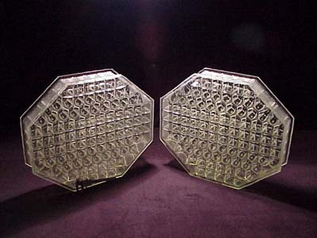
Image of LBT Tertiary (M3) Mirrors, courtesy of HexTek

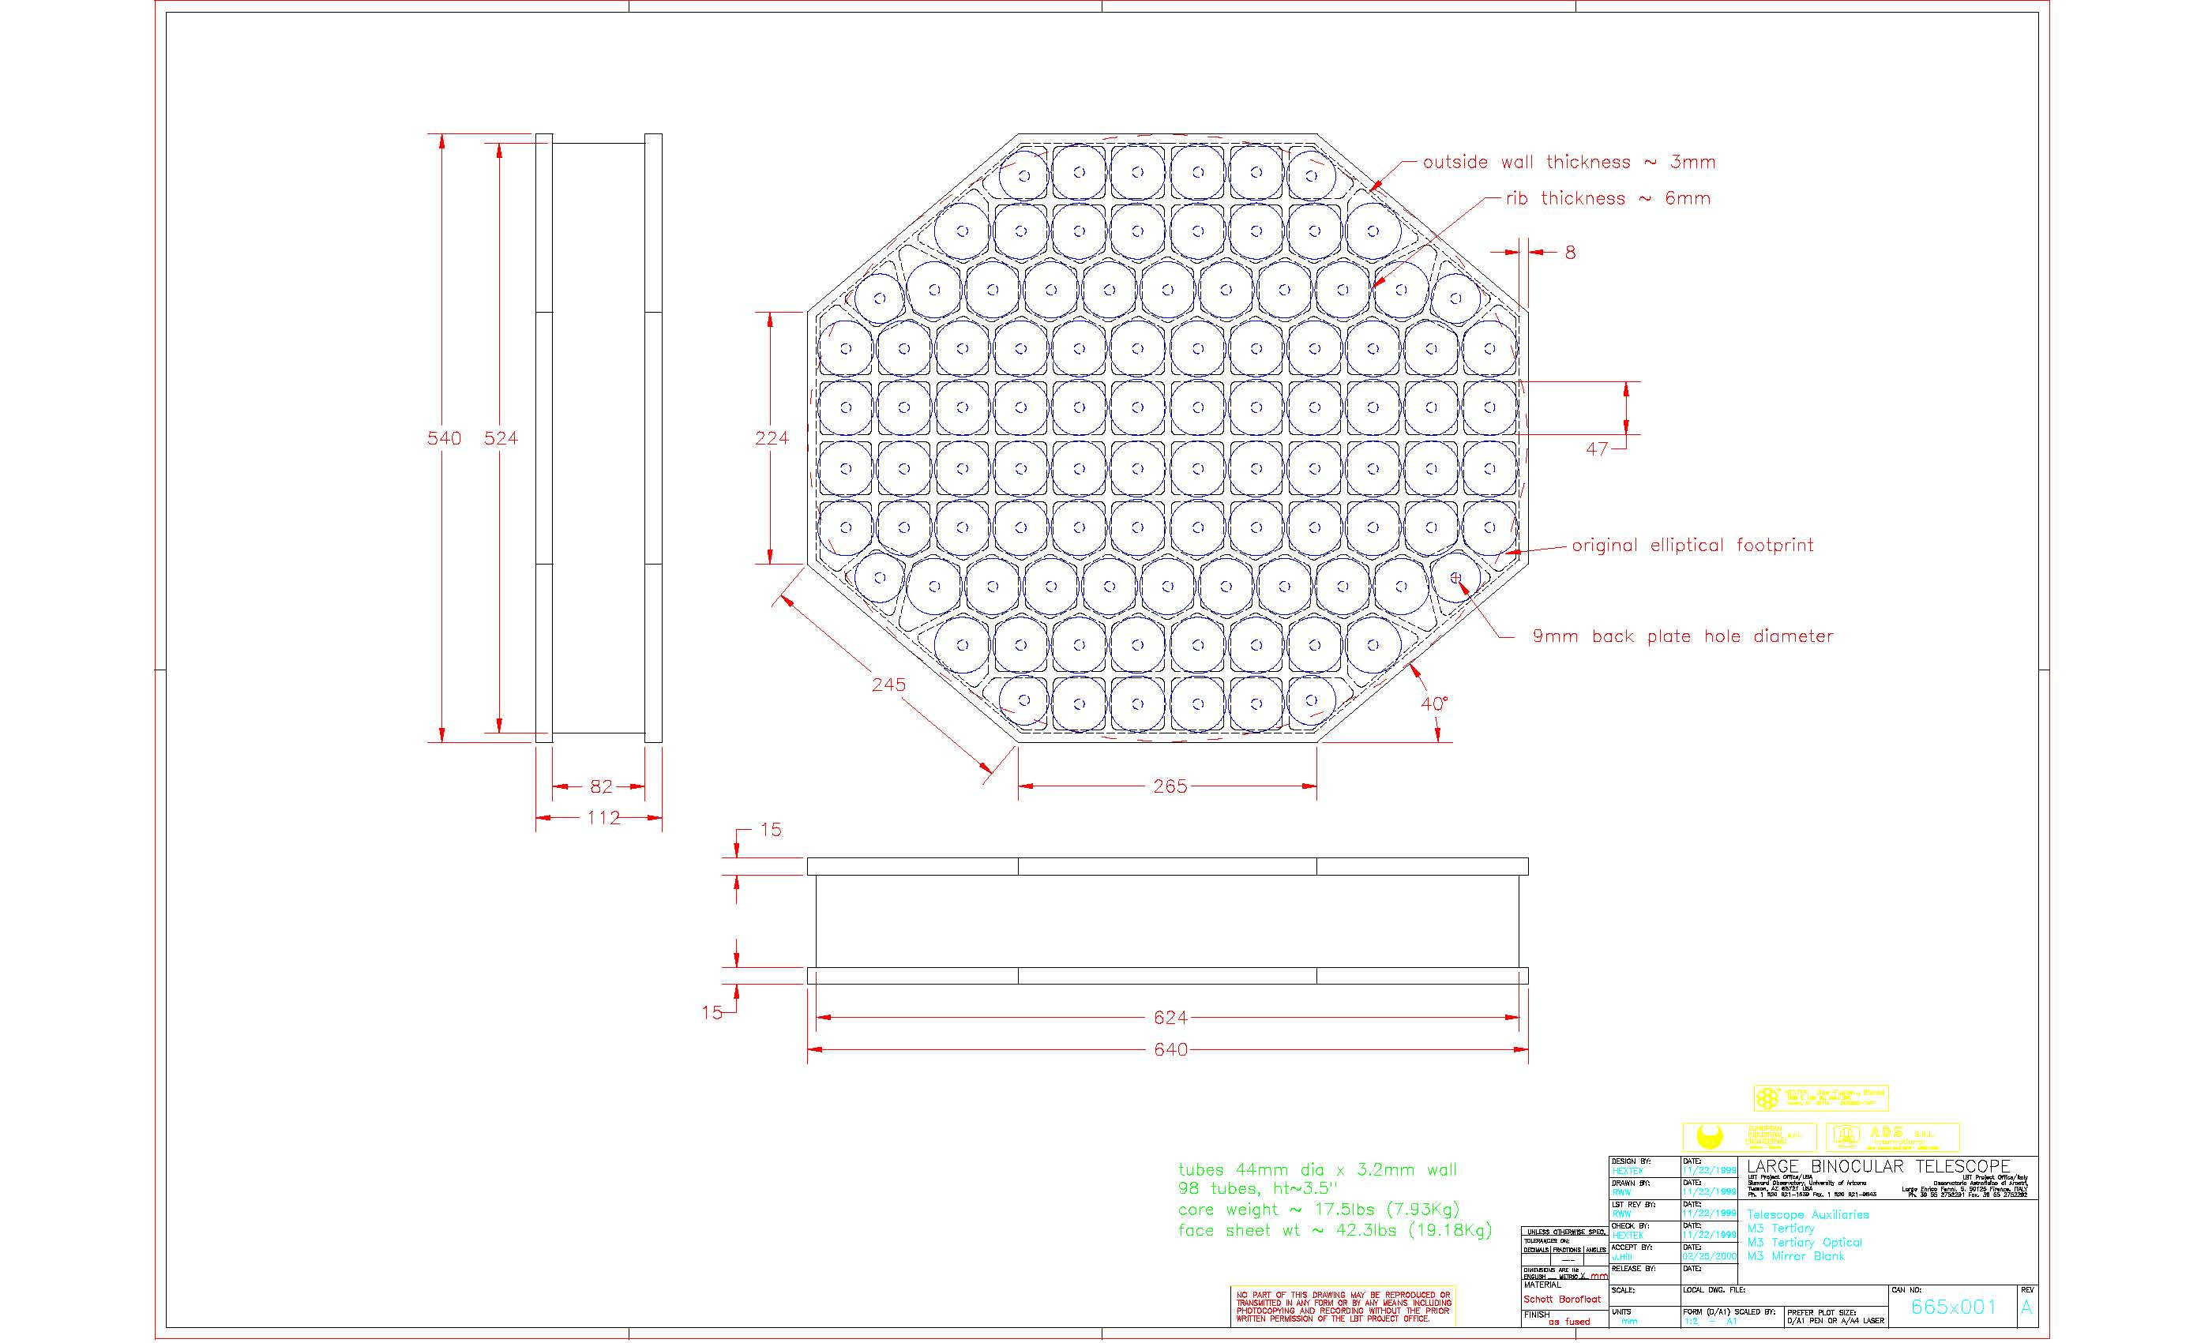
Tertiary Mirror Dimensional Drawing
(Included as attached .pdf file)

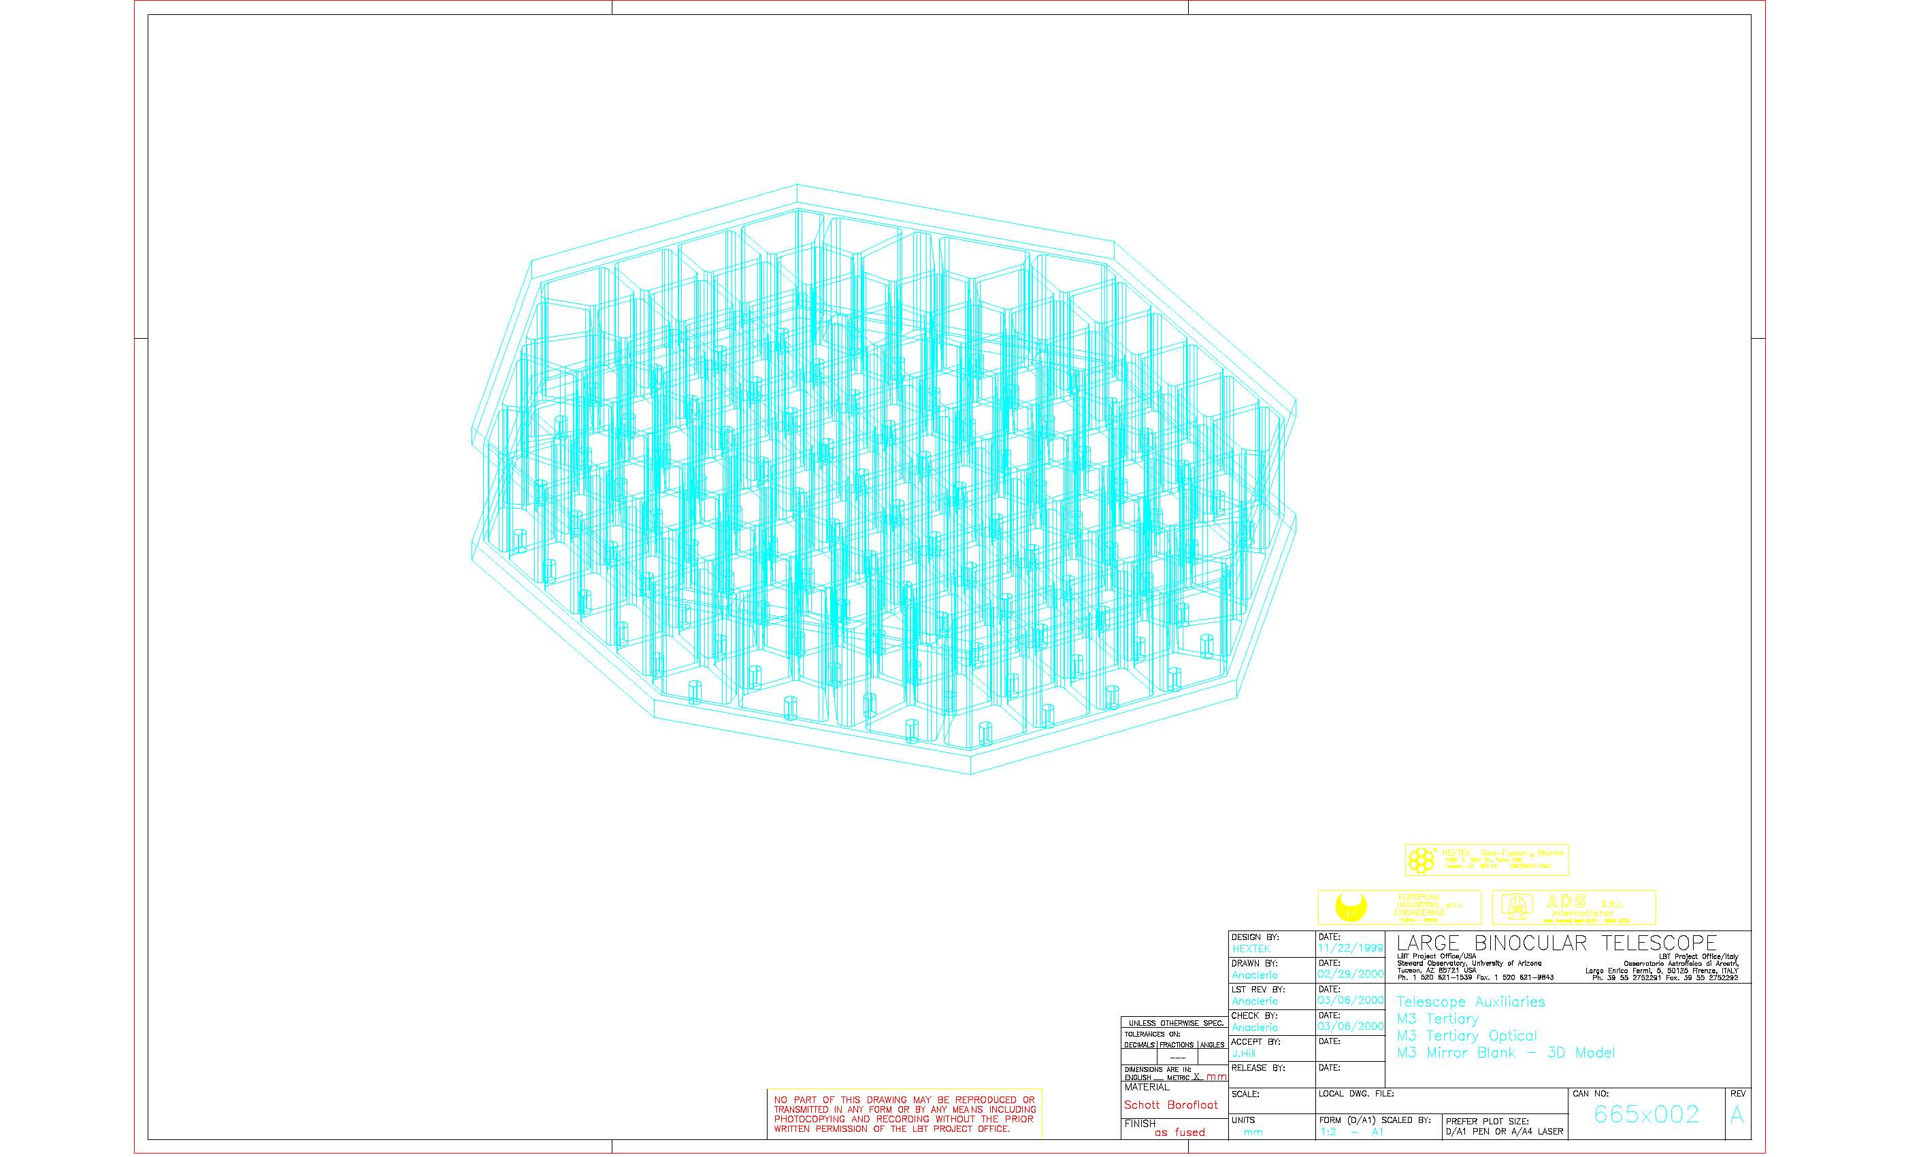
Tertiary Mirror Structural Drawing
(Included as attached .pdf file)

- References

- J. M. Hill, “Error Budget and Wavefront Specifications for Primary and Secondary Mirrors”, Technical Memo, UA-94-01, August 26, 1994

- J. M. Hill, “Mirror Support System for Honeycomb Mirror II/R”, Technical Memo, UA-95-02, December 20, 1995

- J. M. Hill, “Telescope Specifications for Large Binocular Telescope”, Technical Memo, UA-98-01, July 6, 1998

- J. M. Hill, “Polishing Specification for LBT672 F/15 Adaptive Secondaries”, CAN# 645s001c, July 30, 2002

- D. Gallieni, “Technical Report of M3 Unit”, CAN# 660a005c, March 2002

- D. Gallieni, “Structural Design of M3 Unit ‘As Built’ Configuration”, 660a125a, March 25, 2002

- T. M. Herbst, et al, “LINC-NIRVANA, a Fizeau Beam Combiner for the Large Binocular Telescope”, SPIE Vol. 4838, 2003

- S. West, S. Miller, “1.8M Flat Mirror Polishing Specification”, LOTIS Program, May 4, 2005

- D. Gallieni, “Installation Manual of M3 Units”, May 19, 2005

- LUCIFER website, www.mpe.mpg.de/ir/lucifer

--oOo--

Doc_info_start
Title: Technical Specifications: Generating, Polishing, and Testing of LBT Tertiary (M3) Mirrors
Document Type: Specification
Source: Steward Observatory
Issued by: Oli Durney
Date_of_Issue: November 18, 2005
Revised by: Robert Meeks
Date_of_Revision: October 26, 2006
Checked by: John Hill
Date_of_Check: December 15, 2005
Accepted by:
Date_of_Acceptance:
Released by: John Hill
Date_of_Release: October 26, 2006
File Type: MS Word
Local Name: Technical Specifications: Generating, Polishing, and Testing of LBT Tertiary (M3) Mirrors
Category: Telescope Auxiliaries
Sub-Category: M3 Tertiary
Assembly: M3 Tertiary Polish
Sub-Assembly: Specification
Part Name:
CAN Designation: 665s010
Revision: F
Doc_info_end

